SECTION A (40 MARKS)
1. Name the component of air that supports burning.
_________________________________________________________________________
2. What is poultry? __________________________________________________________
_________________________________________________________________________
3. State the main use of leaves to a plant.
_________________________________________________________________________
4. How is a trowel useful to a farmer?
_________________________________________________________________________
5. What is an apiary? _________________________________________________________
_________________________________________________________________________
6. How are the kidneys useful in our bodies?
_________________________________________________________________________
7. State one use of sand soil to people.
_________________________________________________________________________
8. State one cause of swarming in bees.
_________________________________________________________________________
9. Why do bees visit flowers?
_________________________________________________________________________
10. Why do we bathe daily?
_________________________________________________________________________
11. Why do plants grow plenty of leaves during the rainy weather?
_________________________________________________________________________
12. State one block in the village food path.
_________________________________________________________________________
13. How is a rain gauge useful to a farmer?
_________________________________________________________________________
14. Why do farmer carry out cross breeding in poultry?
_________________________________________________________________________

Use the diagram below to answer question 15.

air bubbles

lamp of soil
15. What does the experiment above show about soil?
_________________________________________________________________________
16. Write CC in full as applied in measurement.
_________________________________________________________________________
17. Name one process that takes place in the ileum.
_________________________________________________________________________
18. Give one way of caring for our teeth.
_________________________________________________________________________
19. Why is the hutch of rabbit raised?
_________________________________________________________________________
20. Explain what is meant by the term “vices” as used in poultry keeping.
_________________________________________________________________________
_________________________________________________________________________
21. What is a first aid kit?
_________________________________________________________________________
_________________________________________________________________________
22. State one activity done by man that destroys the environment.
_________________________________________________________________________
23. Identify one way of controlling weeds in the garden.
_________________________________________________________________________
24. How is the pollen basket useful to a honey bee?
_________________________________________________________________________
25. How is burning similar to rusting?
_________________________________________________________________________

26. State one way of preserving food.
_________________________________________________________________________
27. Why do some objects float on water?
_________________________________________________________________________
28. What is the use of a clinical thermometer?
_________________________________________________________________________
29. State one health activity done after visiting a latrine or latrine.
_________________________________________________________________________
30. State one advantage of artificial incubation.
_________________________________________________________________________
31. How do plants benefit from animals?
_________________________________________________________________________
32. Give one viral disease that affects birds.
_________________________________________________________________________
33. How do mushrooms reproduce?
_________________________________________________________________________
34. Give one characteristic of insect pollinated flowers.
_________________________________________________________________________
35. Which immunisable diseases causes lameness in infants?
_________________________________________________________________________
36. What is the role of a queen been in the hive?
_________________________________________________________________________
37. Why do layers sometimes lay eggs with soft shells?
_________________________________________________________________________
38. Where does digestion of food begin in human being?
_________________________________________________________________________
39. How is debeaking of birds important in poultry?
_________________________________________________________________________
40. What is mass? _____________________________________________________________
_________________________________________________________________________
SECTION B (60 MARKS)
41. a) What is the use of chlorophyll during photosynthesis?
_________________________________________________________________________
b) State two raw materials needed for photosynthesis.
i) _________________________________ ii) ______________________________
c) How does man benefit from the process of photosynthesis?
_________________________________________________________________________
42. a) Apart from chicken and ducks, give any other example of poultry.
_________________________________________________________________________
b) Mention any one food product got from chicken.
_________________________________________________________________________
c) State any two types of chicken.
i) _________________________________ ii) ______________________________
43. a) What do queen bees feed on?
_________________________________________________________________________
b) Mention two uses of honey.
i) _________________________________ ii) ______________________________
c) Apart from honey, give any other product got from bees.
_________________________________________________________________________
44. a) Who is a casualty?____________________________________________________
_________________________________________________________________________
b) Write one of the 3B’s in giving of first Aid to casualties.
_________________________________________________________________________
c) Which structure is used by first Aiders to carry casualties?
_________________________________________________________________________
d) Write one cause of accidents at home.
_________________________________________________________________________
45. a) What is soil erosion?__________________________________________________
_________________________________________________________________________

b) State one agent of soil erosion.
_________________________________________________________________________
c) Give one cause of soil erosion.
_________________________________________________________________________
d) Identify one use of mulching.
_________________________________________________________________________
46. a) What is dehydration? _________________________________________________
_________________________________________________________________________
b) Mention two solutes used to make ORS.
i) _________________________________ ii) ______________________________
c) State one cause of dehydration.
_________________________________________________________________________
47. a) Besides using dustbins, give another way in which rubbish can be properly
disposed of.
_________________________________________________________________________
b) Give two ways of promoting personal hygiene.
i) ____________________________________________________________________
ii) ____________________________________________________________________
c) Describe one way of keeping your home clean.
_________________________________________________________________________
48. a) What is kindling in rabbits? ____________________________________________
_________________________________________________________________________
b) Mention two exotic breeds of rabbits.
i) _________________________________ ii) ______________________________
c) Give one way of caring for rabbits.
_________________________________________________________________________
49. Give the function of the following body organs.
i) heart _______________________________________________________________
ii) brain _______________________________________________________________
iii) liver ________________________________________________________________
iv) kidneys _____________________________________________________________
50. a) Name the gas that occupies the least percentage in the atmosphere.
_________________________________________________________________________
b) What is the percentage of nitrogen in the atmosphere?
_________________________________________________________________________
c) Identify two examples of rare gases.
i) _________________________________ ii) ______________________________
51. a) Why is it important to eat a balanced diet?
_________________________________________________________________________
b) Mention two classes food that make up a balanced diet.
i) _________________________________ ii) ______________________________
c) What food value do we get from eating fish?
_________________________________________________________________________
52. a) What name is given in the head of a tape worm?
_________________________________________________________________________
b) How do tape worms enter our bodies?
_________________________________________________________________________
c) What do tapeworms feed on?
_________________________________________________________________________
d) Name one other intestinal worm besides tape worms.
_________________________________________________________________________
53. a) What is immunity?
_________________________________________________________________________
_________________________________________________________________________
b) Mention the two types of immunity.
i) _________________________________ ii) ______________________________
c) Give one reason why children are immunised.
_________________________________________________________________________

54. Use the diagram below to answer questions that follow.
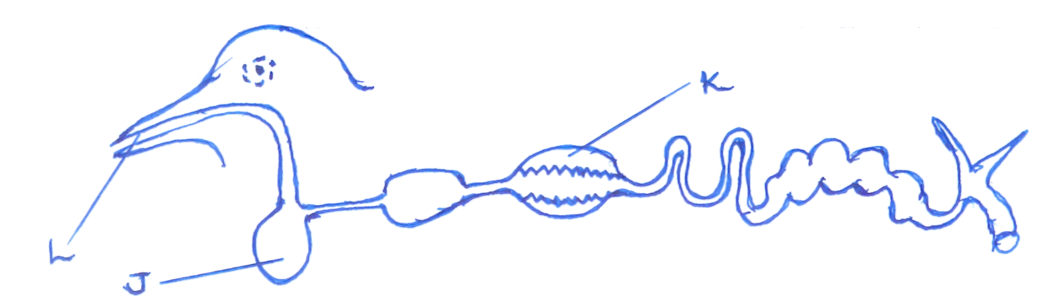

- Name the parts labelled L and J.
i) L ________________________________ ii) J ____________________________
b) How is part marked L useful to a bird?
_________________________________________________________________________
c) Use letter X to show the part where digestion of food end.
55. a) What is food path?
_________________________________________________________________________
_________________________________________________________________________
b) State two ways of caring for crops in the garden.
i) ____________________________________________________________________
ii) ____________________________________________________________________
c) Identify one type of food path you know.
_________________________________________________________________________
Good luck!

